Enabling Water Reuse on Green Roofs with IoT Monitoring and Control
Project name: Enabling Water Reuse on Green Roofs with IoT Monitoring and Control
Authors: Akash Gaur, Ryan Verhoog
Target grade: 5

1. System description (overview – one paragraph)
The proposed system is an IoT-based monitoring and control system designed to support water reuse on a green roof. The overall purpose of the system is to collect environmental and hydrological data from the green roof, process this data, and use it to safely control irrigation using harvested rainwater. The system consists of distributed sensor nodes installed on the green roof, a local gateway, and a cloud platform for visualization and supervision. Together, these parts form one coherent system that enables data collection, data transmission, visualization, and automated irrigation control while ensuring reliable operation under varying environmental and network conditions.

2. System overview diagram (hardware and software parts)
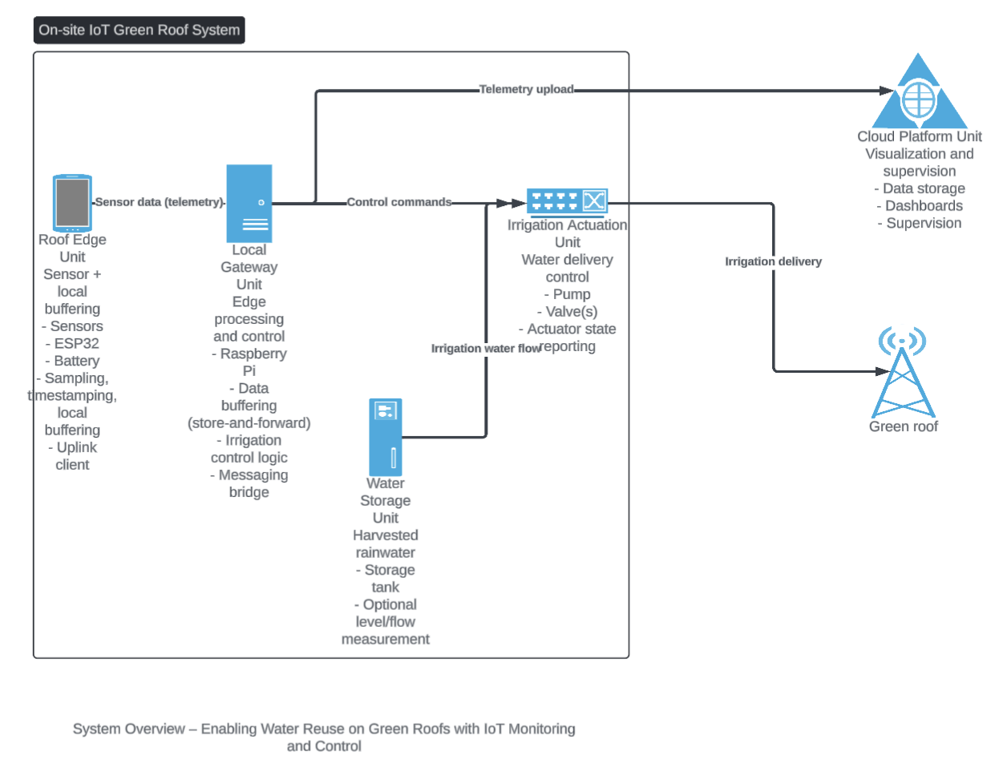

3. System-level requirements
Wording rule (per feedback): avoid writing “The system shall…”. Use the unit name that provides the functionality, and reuse the same unit names in the figure and text.

Grade 3 requirements
G3-1. Roof Edge Unit shall collect sensor data from the green roof.
G3-2. Roof Edge Unit shall transmit sensor data to the Local Gateway Unit.
G3-3. Local Gateway Unit shall forward sensor data to the Cloud Platform Unit for visualization.
G3-4. Cloud Platform Unit shall visualize measured data in a dashboard.

Grade 4 requirements
G4-1. Local Gateway Unit shall control irrigation based on soil moisture measurements.
G4-2. Local Gateway Unit shall prevent unsafe irrigation by stopping the Irrigation Actuation Unit to avoid pump dry-run and water overflow.
G4-3. Roof Edge Unit shall buffer sensor data locally during temporary network outages.
G4-4. Local Gateway Unit shall buffer incoming sensor data and resume upload to the Cloud Platform Unit after connectivity is restored.

Grade 5 requirements
G5-1. Local Gateway Unit shall demonstrate reliable data delivery to the Cloud Platform Unit with minimal data loss during normal operation.
G5-2. Local Gateway Unit shall quantify reused water volume delivered via the Irrigation Actuation Unit from the Water Storage Unit.
G5-3. Roof Edge Unit shall operate on battery power for multiple days without maintenance.
G5-4. The project shall provide documented and reusable hardware and software architecture suitable for replication.

4. Target grade
The project targets Grade 5.

